**Software Requirements**

**Specification**

**for**

**Twenty Questions**

**Version 1.5**

**Prepared by**

**Group Name: CEQ**

|  |  |
| --- | --- |
| **Caela Goins** | **840199411** [**cbg013@bravemail.uncp.edu**](mailto:cbg013@bravemail.uncp.edu) |
| **Edwin Catalan** | **840178296** [**egc008@bravemail.uncp.edu**](mailto:egc008@bravemail.uncp.edu) |
| **Quadre Jackson** |  |
|  | **Instructor: Dr. Mohan**  **Course: Advanced Software Project**  **Lab Section: *CSC-4900-001***  **Date: 1/23/2023** |

# **Contents**

|  |  |  |  |
| --- | --- | --- | --- |
| **Version** | **Primary Author(s)** | **Description of Version** | **Date Completed** |

## ***Software Requirements Specification for Twenty Questions*** ***Page 2***

**CONTENTS**  **II**

**REVISIONS**  **II**

**1** **INTRODUCTION** **1**

1.1 DOCUMENT PURPOSE 1

1.2 PRODUCT SCOPE 1

1.3 INTENDED AUDIENCE AND DOCUMENT OVERVIEW 1

1.4 DEFINITIONS, ACRONYMS AND ABBREVIATIONS 1

1.5 DOCUMENT CONVENTIONS 1

1.6 REFERENCES AND ACKNOWLEDGMENTS 2

**2** **OVERALL DESCRIPTION 2**

2.1 PRODUCT OVERVIEW 2

2.2 PRODUCT FUNCTIONALITY 3

2.3 DESIGN AND IMPLEMENTATION CONSTRAINTS 3

2.4 ASSUMPTIONS AND DEPENDENCIES 3

**3** **SPECIFIC REQUIREMENTS**  **4**

3.1 EXTERNAL INTERFACE REQUIREMENTS 4

3.2 FUNCTIONAL REQUIREMENTS 4

3.3 USE CASE MODEL 5

**4** **OTHER NON-FUNCTIONAL REQUIREMENTS**  **6**

4.1 PERFORMANCE REQUIREMENTS 6

4.2 SAFETY AND SECURITY REQUIREMENTS 6

4.3 SOFTWARE QUALITY ATTRIBUTES 6

**5** **OTHER REQUIREMENTS 7**

**APPENDIX A – DATA DICTIONARY**  **8**

**APPENDIX B - GROUP LOG**  **9**

## ***Software Requirements Specification for Twenty Questions*** ***Page 3***

|  |  |
| --- | --- |
| **1** | **Introduction** |

## **1.1 Document Purpose**

The purpose of this document is to build an online video game for use on a computer. The title of this game is Twenty Questions. The purpose of Twenty Questions is to provide entertainment to users with various categories of guessing what the user is thinking of. This document will describe the entire system to be created.

## **1.2 Product Scope**

The purpose of the online video game Twenty Questions is to provide challenging gameplay for the user. The game does not have levels, instead the game will ask questions relating to a category of the user’s choice. The goal of the game is to answer all the questions without the game guessing what the user is thinking in relation to the chosen category. The benefits provided by this game are presented as customizations that offer avatars and other accessories.

## **1.3 Intended Audience and Document Overview**

This project is intended for a college presentation to the professor and may be found useful to classmates or potential clients. Section 2 provides an overall description of the project and general assumptions or functionality. Section 3 outlines the project’s specific requirements. Section 4 details the non-functional requirements of the project.

## **1.4 Definitions, Acronyms and Abbreviations**

There are currently no definitions, acronyms, or abbreviations necessary for the project documentation.

## **1.5 Document Conventions**

This document follows IEEE formatting conventions. Document text uses Arial font size 11 or 12. Comments for the document are italicized. Overall, the document is single spaced and maintains 1” margins.

## **1.6 References and Acknowledgments**

*No references or acknowledgments necessary at this time.*

|  |  |
| --- | --- |
| **2** | **Overall Description** |

## **2.1 Product Overview**

This online video game is a self-contained product created with Web development and database tools. As a result, the product requires a link to open and utilize it. Twenty Questions is accessed on a 64-bit Operating system, and utilizes the keyboard and mouse to operate the game.

## **2.2 Product Functionality**

* Menu Displays: The system should display the correct sequence of screens as directed by player input.
* Player Controls and Abilities: The system should allow player input and access to menu screens as directed by player input.
* Menu Controls and Abilities: The system should display proper buttons and text boxes as predetermined by developers.
* Customization Collection: The system should display appropriate custom options and their previews as the player progresses in the game.
* Score Counter: The system should correctly increment the score count as the player progresses.
* Question Management: The system should accurately track the question count as the game progresses.
* Database Access: The system should accurately access and modify the database as needed.

## **2.3 Design and Implementation Constraints**

Design of software will be done in HTML, so utilization of in engine functions must be understood and manipulated.

## **2.4 Assumptions and Dependencies**

* Software is restricted to 2D graphics based on the limitations of HTML and CSS. .

|  |  |
| --- | --- |
| **3** | **Specific Requirements** |

## **3.1 External Interface Requirements**

### **3.1.1 User Interfaces**

Players will interact with the video game with buttons on screen that they can click on to answer a question given by the game. The keyboard can be used later to type in an animal that is not in the preset database.

### **3.1.2 Hardware Interfaces**

The physical hardware used to interact with this product will be a Windows OS computer with a mouse and keyboard or a laptop with touchpad and keyboard.

### **3.1.3 Software Interfaces**

This software requires a Windows operating system to run properly.

## **3.2 Functional Requirements**

- A user shall log in or create an account

- System shall check for or create a new account

- A user shall view their player profile

- A user shall select a category

- A user shall begin answering questions

- System shall display appropriate guesses

- A user shall enter their guess upon winning

- System shall update appropriate database with user entry

- System shall update user profile progress

## **3.3 Use Case Model**

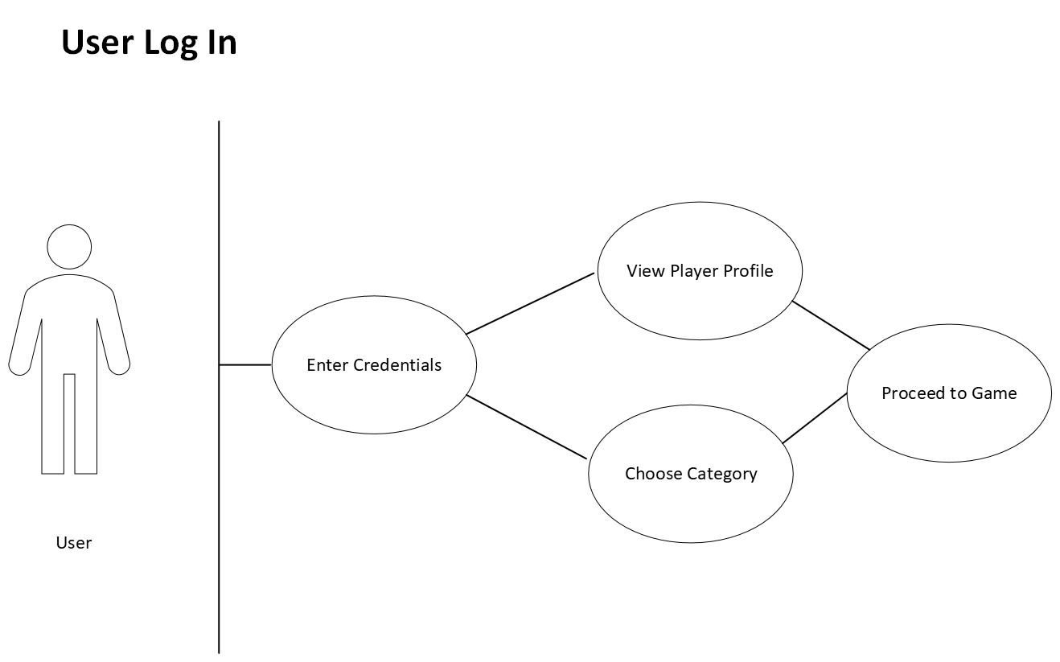

|  |  |
| --- | --- |
| Name: | User Log In |
| Actor: | Client |
| Pre-Conditions: | Access website link |
| Post-Conditions: | User logs in or creates an account. |
| Purpose: | Log into or create a new user account. |
| Description: | Client will access webpage, log into system with username and password, and view their player profile, categories, or proceed to game. |
| Alternative Courses: | None, Client has to log in or create account. |
| Errors: |  |

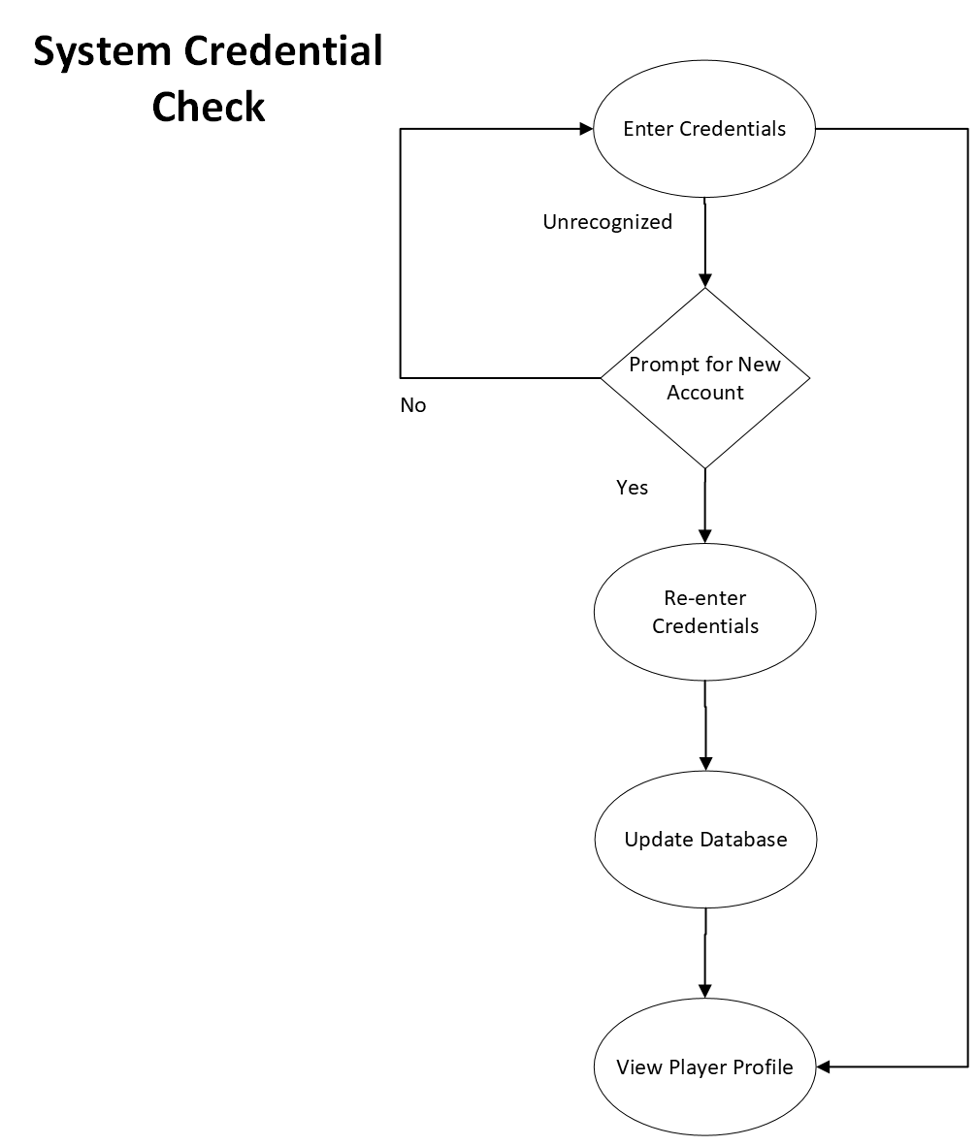

|  |  |
| --- | --- |
| Name: | System Credential Check |
| Actor: | System |
| Pre-Conditions: | Client entered credentials |
| Post-Conditions: | Client is logged on or created an account. |
| Purpose: | System check for existing account. |
| Description: | System will check for existing account and if not found, a new account will be made. |
| Alternative Courses: | None, Client has to log in or create account. |
| Errors: |  |

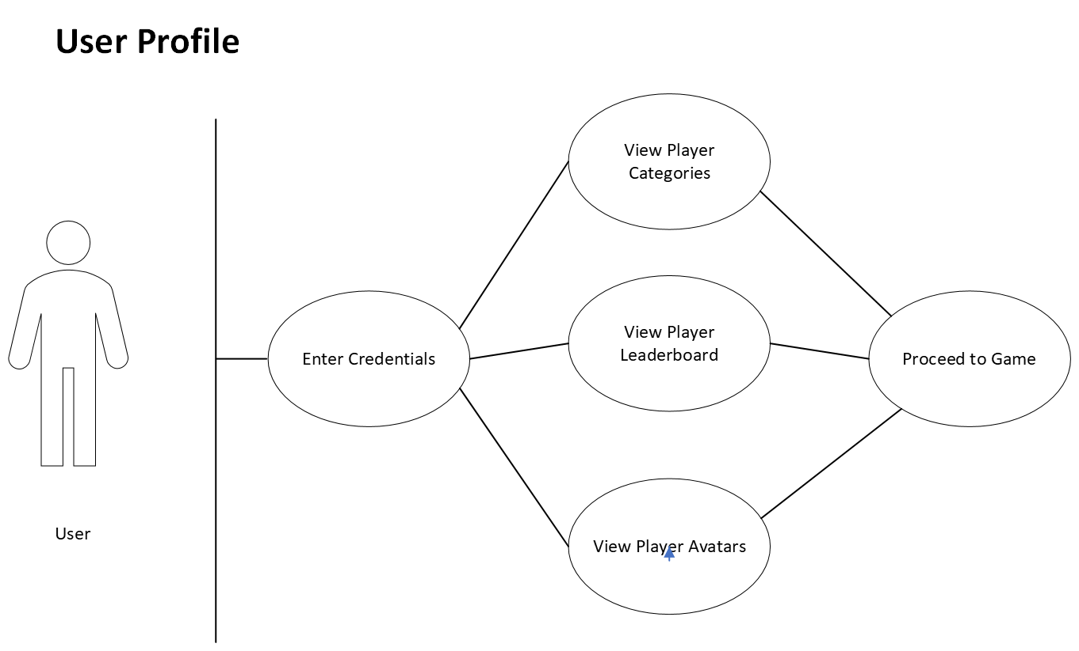

|  |  |
| --- | --- |
| Name: | User Profile |
| Actor: | Client |
| Pre-Conditions: | User logs in |
| Post-Conditions: | User plays game |
| Purpose: | Users view their player profile. |
| Description: | User can view their categories, player leaderboard, and player avatar before proceeding to game. |
| Alternative Courses: | Failed log in |
| Errors: |  |

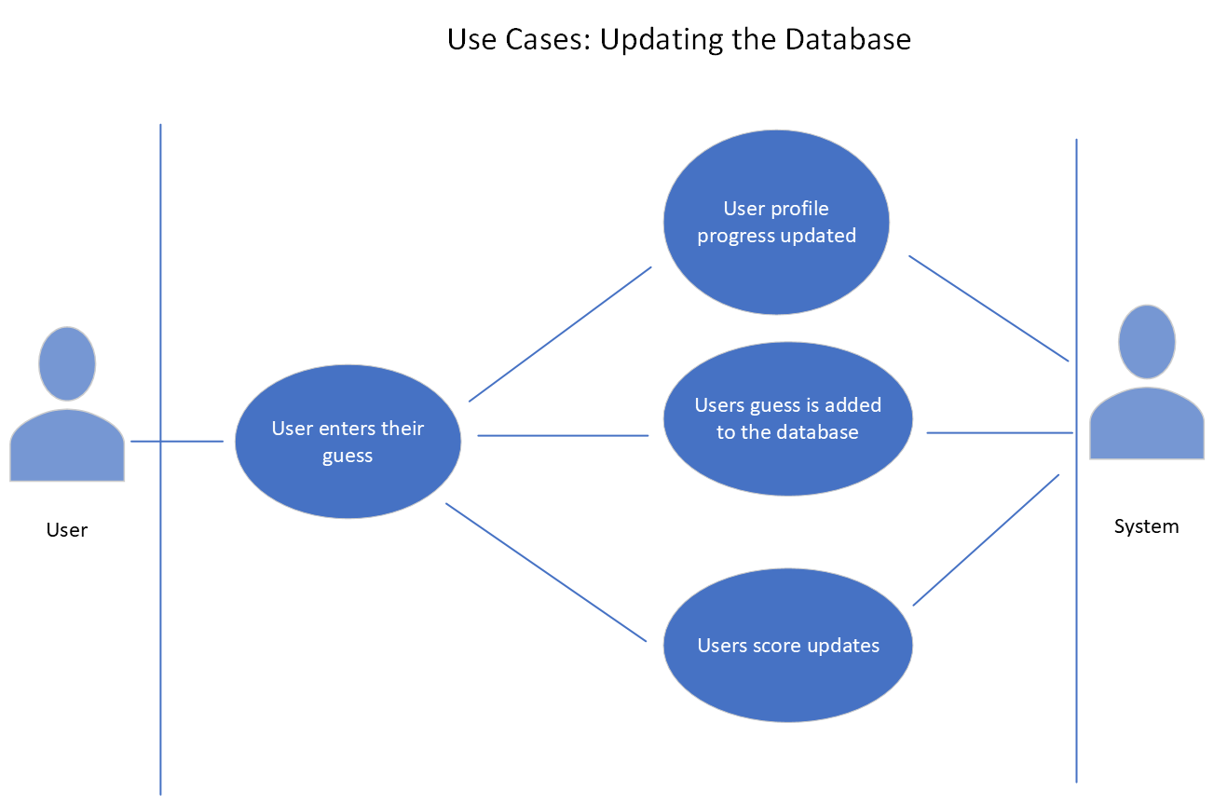

|  |  |
| --- | --- |
| Name: | Update Database |
| Actor: | Client |
| Pre-Conditions: | Successfully log in and the game start. |
| Post-Conditions: | Database has a new entry. |
| Purpose: | User indirectly updates database. |
| Description: | Client will enter the guess the game failed to find and update the database with the new entry. |
| Alternative Courses: | Failed to contact database. |
| Errors: |  |

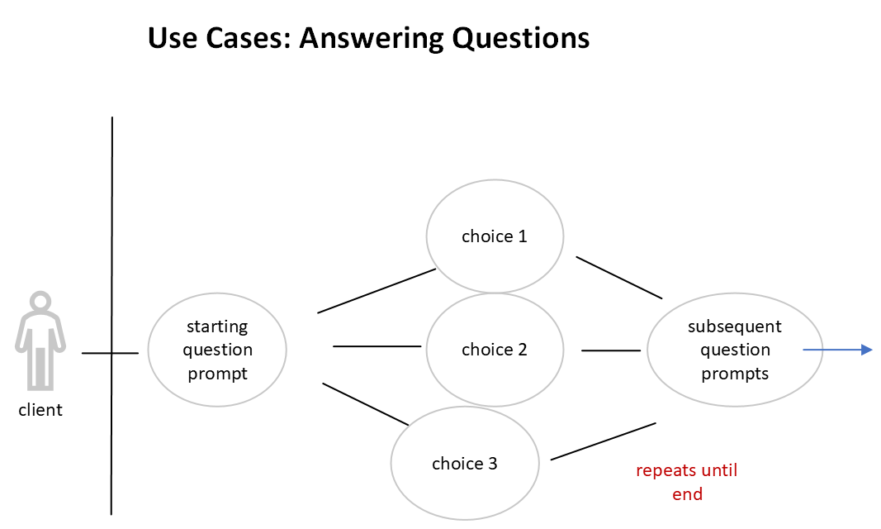

|  |  |
| --- | --- |
| Name: | Answer Questions |
| Actor: | Client |
| Pre-Conditions: | Successfully log in and start the game. |
| Post-Conditions: | Score updates. |
| Purpose: | Users answer questions to gain points. |
| Description: | Client will respond to yes or no questions from the system and proceed to another question based on their response. |
| Alternative Courses: | Website crash. |
| Errors: |  |

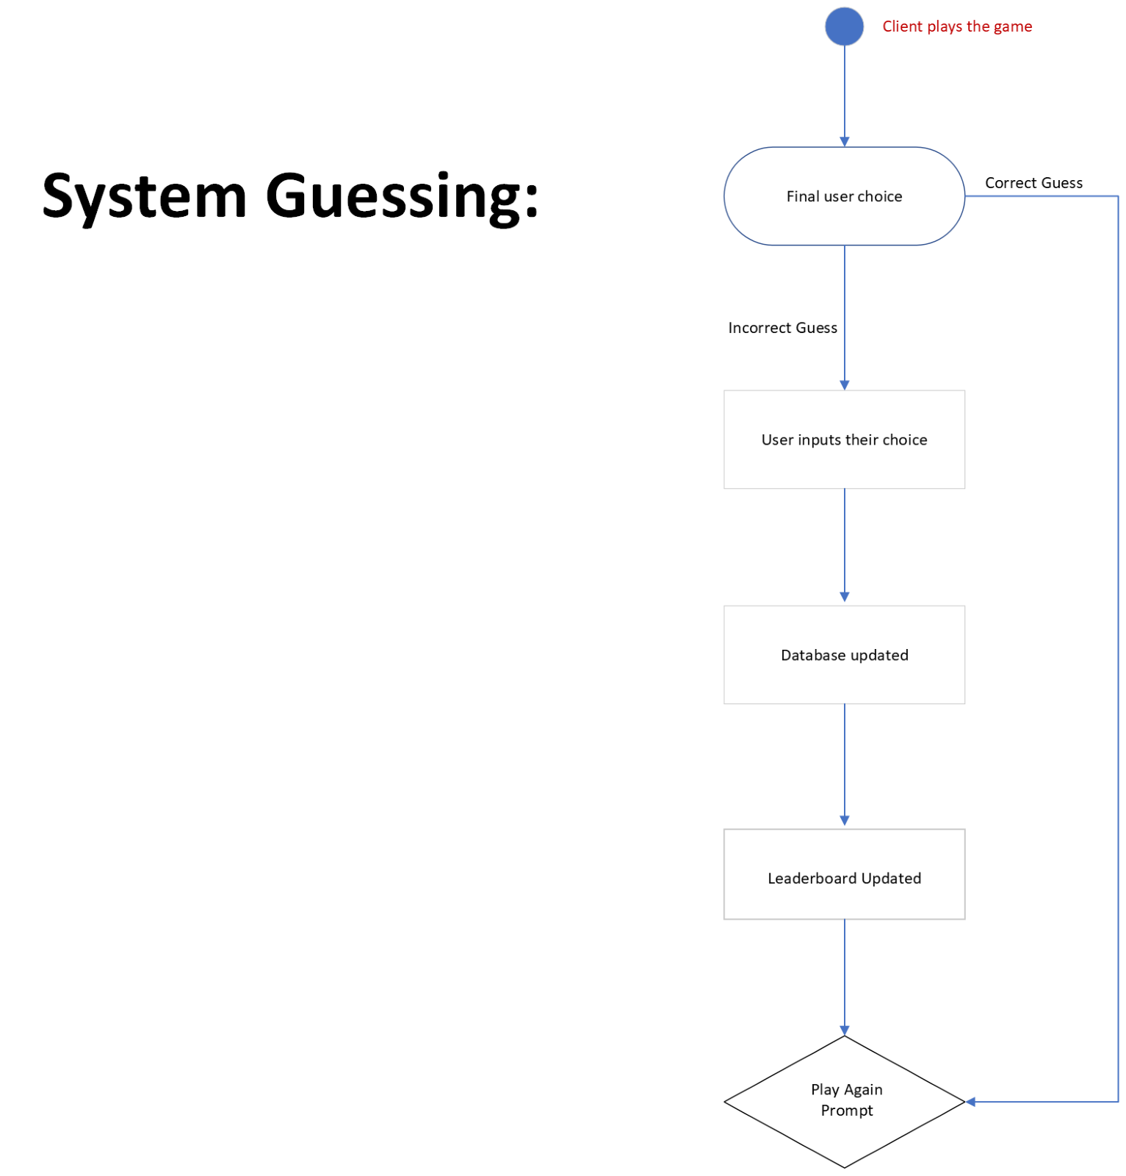

|  |  |
| --- | --- |
| Name: | System Guess |
| Actor: | Client |
| Pre-Conditions: | Successful log in and game start. |
| Post-Conditions: | User score changes. |
| Purpose: | System tries to guess answer based on User response. |
| Description: | Client will respond to questions that the system will then collect and check database for an appropriate guess. If game fails the database may be updated and the game restarted. |
| Alternative Courses: | Failed to contact database. |
| Errors: |  |

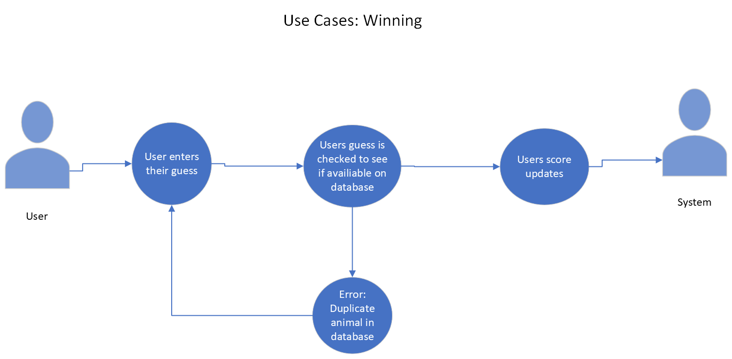

|  |  |
| --- | --- |
| Name: | Win Game |
| Actor: | Client |
| Pre-Conditions: | Successful log in and game start. |
| Post-Conditions: | Score updated. |
| Purpose: | How the user wins the game. |
| Description: | Client will enter the guess the game failed to find and update the database with the new entry if there is no duplicate in the database. User’s score will increase if their guess is unique. |
| Alternative Courses: | Failed to contact database. |
| Errors: |  |

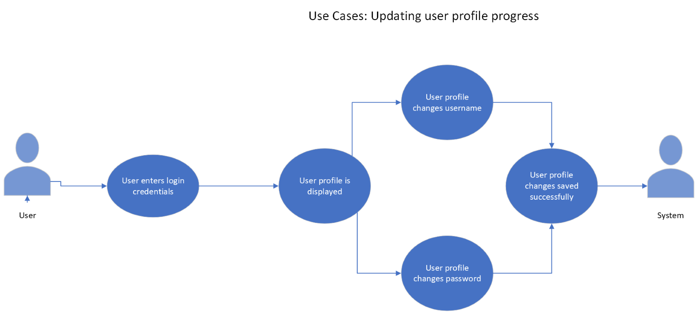

|  |  |
| --- | --- |
| Name: | Update User Profile |
| Actor: | Client |
| Pre-Conditions: | Successful log in and game start. |
| Post-Conditions: | User profile updated. |
| Purpose: | User views their updated player profile. |
| Description: | Client will enter appropriate credentials and has the option to change their username or password. Player can also view any changes to their score or leaderboard. |
| Alternative Courses: | Failed log in. |
| Errors: |  |

|  |  |
| --- | --- |
| **4** | **Other Non-functional Requirements** |

## **4.1 Performance Requirements**

This software will require Windows to operate, which means meeting its system requirements:

Processor:

* Pentium 4 or higher

Operating System:

* Windows XP
* Windows Vista (32, 64-bit)
* Windows 7 (32, 64-bit)
* Windows 8 (32, 64-bit)

Graphics:

* Capable of high (16-bit) color and 1024 X 768 resolution
* 3D video card recommended

## **4.2 Safety and Security Requirements**

Due to potential unseen bugs, glitches, or unmet hardware requirements, the software has the potential to crash or freeze. This will cause the user to lose progress in the game, as the game only saves after a game over or win state has been reached.

## **4.3 Software Quality Attributes**

**4.3.1 Usability**

This game provides an ease of learning, having simple instructions and controls, having them be of optimum comfort and intuitive. The game is structured in a way that it will be immediately obvious of their goals, thus the learning curve is short.

**4.3.2 Testability**

The game is highly testable, providing detailed errors and situations in which the game can be played. Ease of resetting and resuming the game as the code is compiled is given, making it easy to react to errors that can occur when programming.

**4.3.3 Reusability**

|  |  |
| --- | --- |
| **5** | **Other Requirements** |

*<This section is* ***Optional.*** *Define any other requirements not covered elsewhere in the SRS. This might include database requirements, internationalization requirements, legal requirements, reuse objectives for the project, and so on. Add any new sections that are pertinent to the project.>*

# **Appendix A – Data Dictionary**

*<Data dictionary is used to track all the different variables, states and functional requirements that you described in your document. Make sure to include the complete list of all constants, state variables (and their possible states), inputs and outputs in a table. In the table, include the description of these items as well as all related operations and requirements.>*

***Page***

# **Appendix B - Group Log**

*<Please include here all the minutes from your group meetings, your group activities, and any other relevant information that will assist in determining the effort put forth to produce this document>*